|  |  |
| --- | --- |
| Team ID | PNT2022TMID41951 |
| Project Name | SmartFarmer-IOT Enabled Smart  Farming Application |

**Team Leader :**

**Pavithra.G**

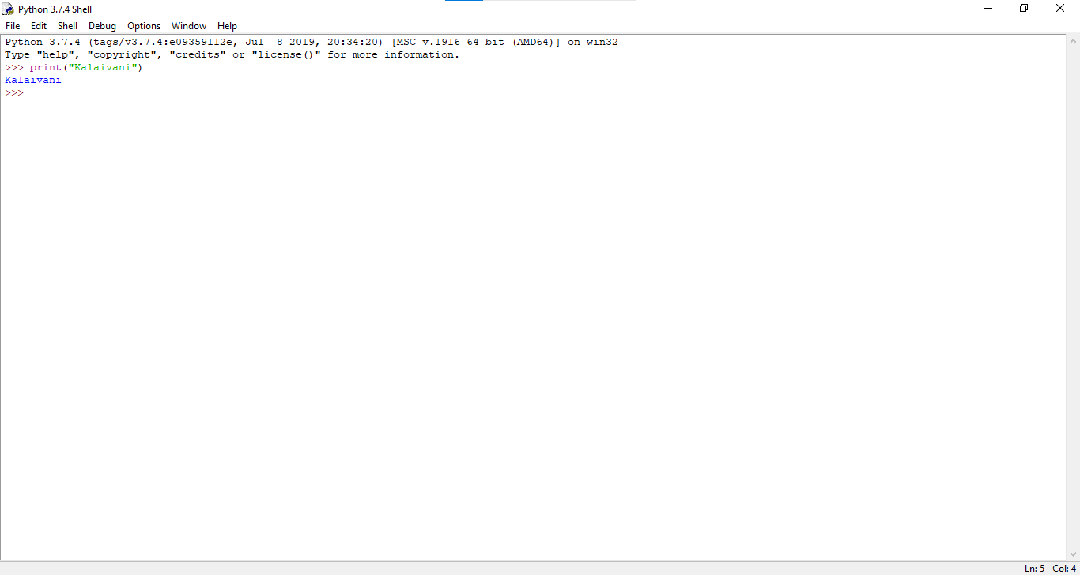

**Our Team Members:**

**Anitha.T**

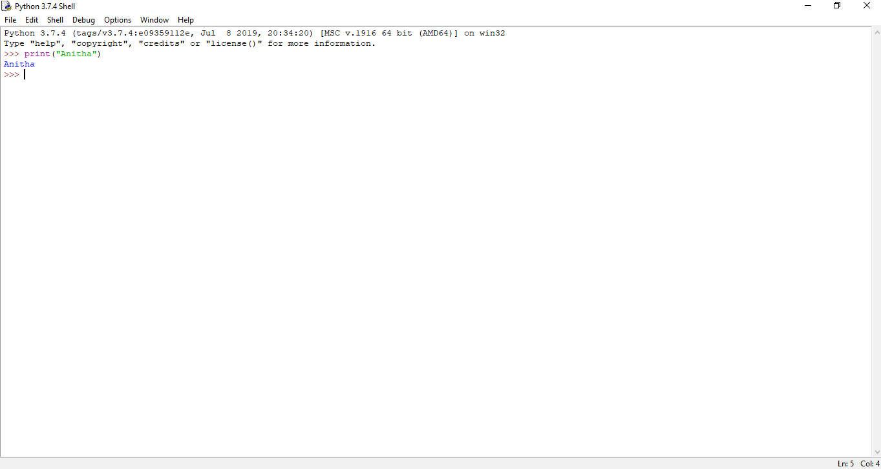

**Kalaivani.V**



**Tharshini Shri.S**

